
Green University of Bangladesh
Department of Computer Science and Engineering(CSE)
Faculty of Sciences and Engineering
Semester: (Spring, Year:2024), B.Sc. in CSE (Day)

LAB ASSIGNMENT NO #05
Course Title: Data Communication Lab
Course Code: CSE 308 Section: 221_D3

Lab Experiment Name: Implementing of Error Detection & Correction
Mechanism using Hamming Code

Student Details

Name |  | ID
1. | Jahidul Islam | 221002504

Lab Date : 23 – 03 – 2024
Submission Date : 27 – 03 – 2024
Course Teacher’s Name : Sakhaouth Hossan

[For Teachers use only: Don’t Write Anything inside this box]

Lab Report Status
Marks: ………………………………… Signature:.....................
Comments:.............................................. Date:..............................

1. TITLE OF THE LAB EXPERIMENT:

Implementing of Error Detection & Correction Mechanism using Hamming Code

2. OBJECTIVES:

After complementing this lab experiment, we will gain practical knowledge and tthe outcomes of this experiment are
- To implement the Error Detection & Correction Mechanism using Hamming Code

3. PROCEDURE:

Hamming Encoder Procedure:

Inputs:
- Binary bit stream to be encoded.
Outputs:
- Encoded data with parity bits.

Procedure Steps:
- Prompt User: Display a message to prompt the user to enter a binary bit stream.
- Input: Accept the binary bit stream input from the user.
- Calculate Parity Bits: Determine the number of parity bits required based on the length of the input data.
- Encode Data:
  - Initialize an array to store the encoded data.
  - Initialize variables for tracking positions of data bits and parity bits.
  - Iterate over each position in the encoded data array:
    - If the position is a power of 2 (parity bit position), skip and increment the parity bit tracker.
    - Otherwise, copy the corresponding data bit from the input stream to the encoded data array and increment the data bit tracker.
- Calculate Parity Bits:
  - For each parity bit position:
    - Calculate the parity by counting the number of '1's in specific combinations of data bits.
    - Set the parity bit to '1' if the count of '1's is odd, otherwise set it to '0'.
- Display Encoded Data: Show the encoded data with parity bits to the user
4. IMPLEMENTATION

#include <iostream>
#include <string>
#include <cmath>

using namespace std;

int calculateParityBits(int m) {
int r = 0;
while (pow(2, r) < m + r + 1) {
r++;
}
return r;
}

string hammingEncode(const string& input) {
int m = input.length();
int r = calculateParityBits(m);

string encodedData(m + r, '0');

int p = 0;
int j = 0;

for (int i = 1; i <= m + r; i++) {
if (i == pow(2, p)) {
p++;
} else {
encodedData[i - 1] = input[j++];
}
}

for (int i = 0; i < r; i++) {
int parityIndex = pow(2, i) - 1;
int count = 0;
for (int j = parityIndex + 1; j <= m + r; j++) {
if ((j & (1 << i)) != 0) {
if (encodedData[j - 1] == '1') {
count++;
}
}
}
if (count % 2 != 0) {
encodedData[parityIndex] = '1';
}
}

return encodedData;
}

void displayBinaryString(const string& binaryString) {
for (char bit : binaryString) {
cout << bit << "";
}
cout << endl;
}

int main() {
string input;
cout << "Enter binary bit stream: ";
cin >> input;

string encodedData = hammingEncode(input);

cout << "Encoded data with parity bits: ";
displayBinaryString(encodedData);

return 0;
}

5. OUTPUT

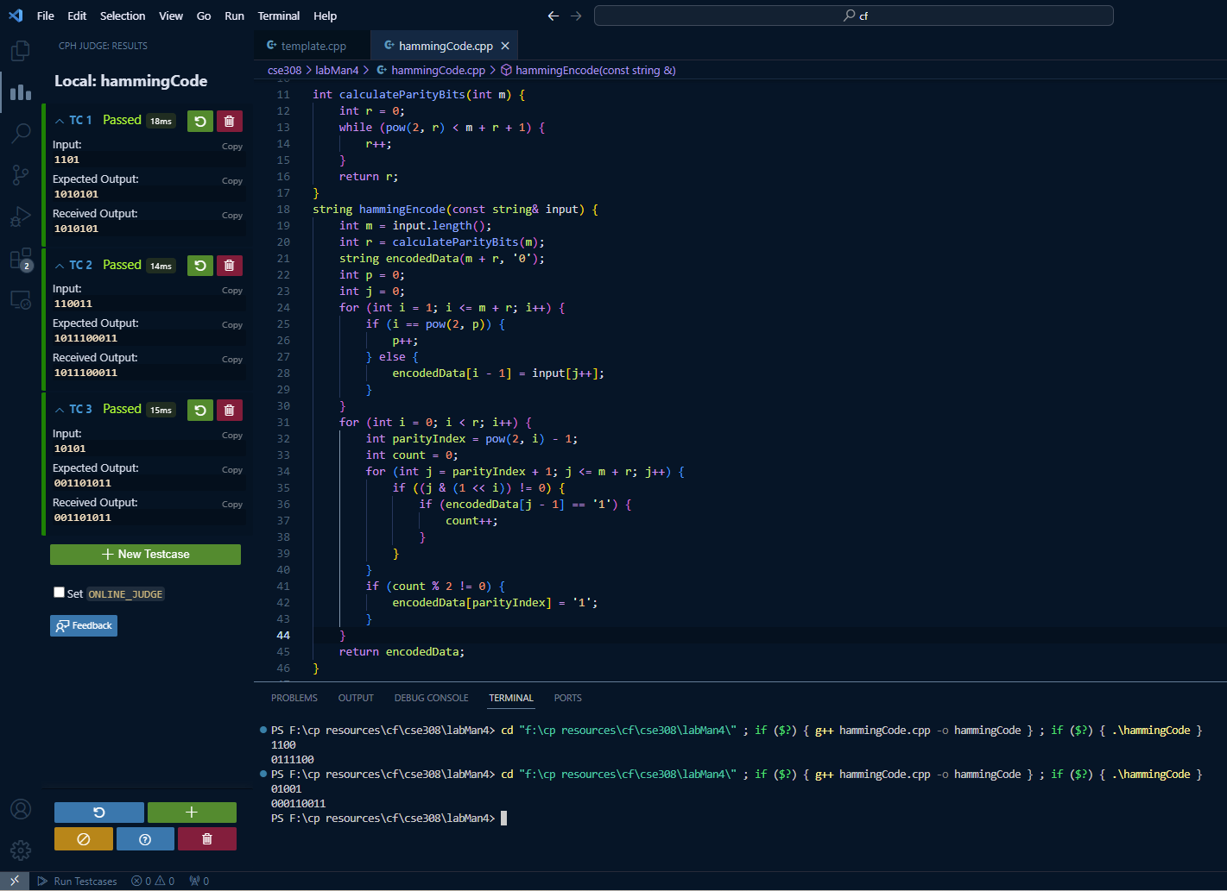

Figure 01: Shows the code and output of this code.

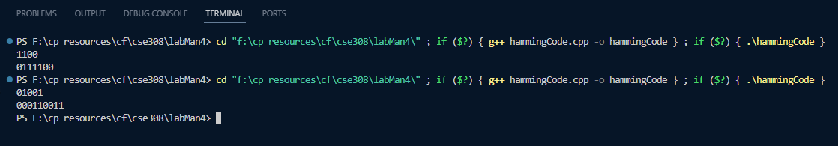
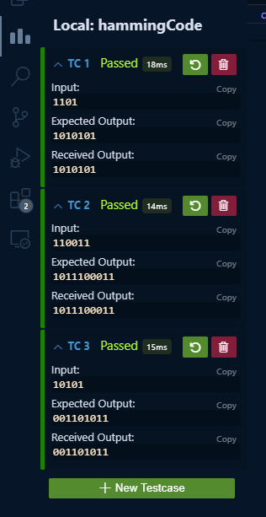
Figure 02: Output of the program.

6. ANALYSIS AND DISCUSSION:

Hamming code is effective for single-bit error detection and correction but has limitations with multiple-bit errors.

